Android Exercises

Layouts in Android

* A type of resource that defines what is drawn on the screen. Layout resources are stored as XML files in the /res/layout resource directory for the application. A layout resource is simply a template for a user interface screen, or portion of a screen, and contain.
* A type of View class whose primary purpose is to organize other controls. These layout classes (LinearLayout, RelativeLayout, TableLayout, etc. ) are used to display child controls, such as text controls or buttons or images on the screen.

**Frame Layout** : Frame Layout is designed to block out an area on the screen to display a single item.

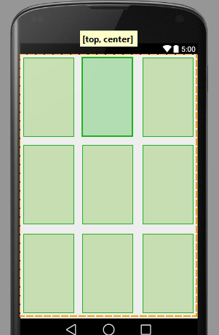

Grid Layout : A layout that places its children in a rectangular grid.

**Linear Layout** : A Layout that arranges its children in a single column or a single row.

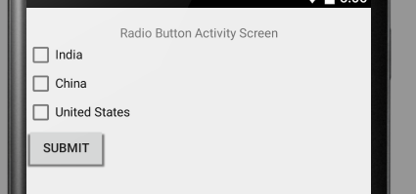

**Relative Layout** : A Layout where the positions of the children can be described in relation to each other or to the parent.

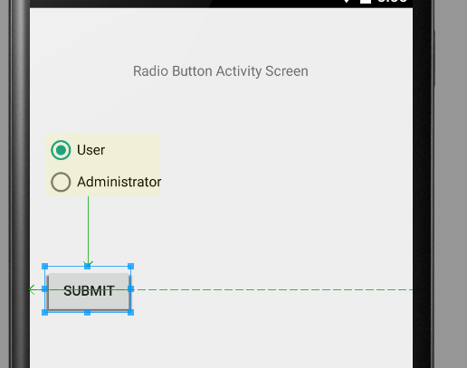

Table Layout : A layout that arranges its children into rows and columns.

**Exercise on different layouts and control handlers in Android:**

1. Create a new project and name it as LayoutDemo

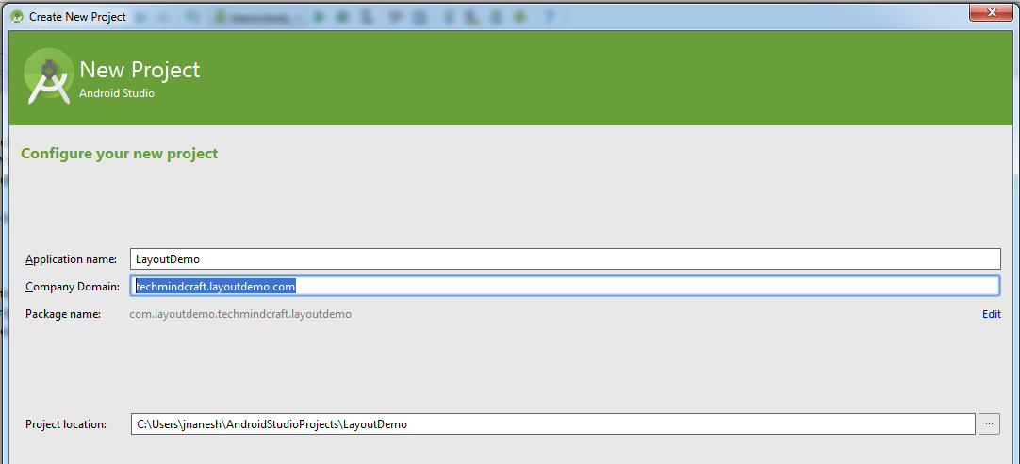

1. Enter the Activity Name as “LayoutActivity”, Layout Name as “activity_layout” and Title as “Layout Activity Demo”

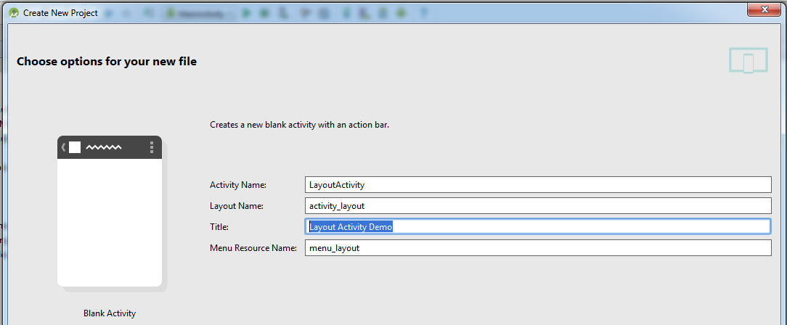

1. In the activity_layout.xml file add a Text View, Radio Group (inside add Radio Button1, Radio Button2) and Button as shown below:

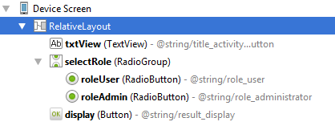

Now your activity_layout.xml file should like as below:

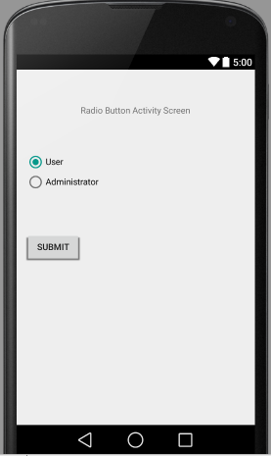

1. Declare the Radio Group, Radio Buttons and Buttons in your class file as below:

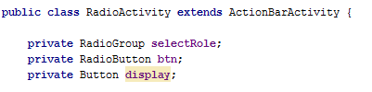

1. Create a reference for the declared variables in your onCreate() method as below:

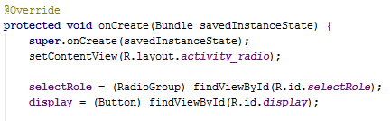

1. Set a onClick listener for display Button in your onCreate method as below:

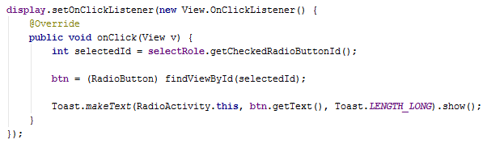

1. Save and Run the application and you will be able to see the below shown output:

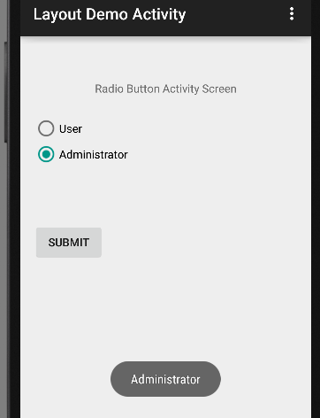

1. Try change your layout from RelativeLayout to LinearLayout and observe the changes in your emulator screen. The output will be similar as below snapshot:

